http://www.ensembl.org/biomart/martview/8d78c5e9573a0a4c5a67c32539df1688

Mouse platform : GPL1261 [Mouse430_2] Affymetrix Mouse Genome 430 2.0 Array

Filter Gene → Input microarray probes/probesets ID list → AFFY MOE430B probe ID(s)
Upload data file: GPL1261.txt
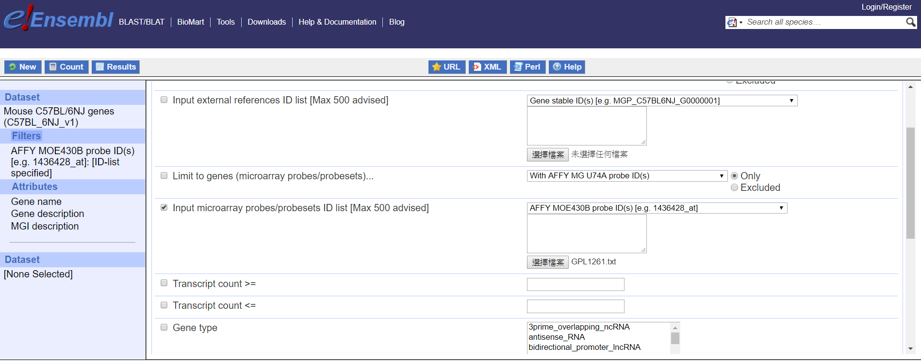
Click Attributes → GENE → Gene name,
EXTERNAL → MGI description, AFFY MOE430B probe

Click count to pre-count
Click Results to show results
